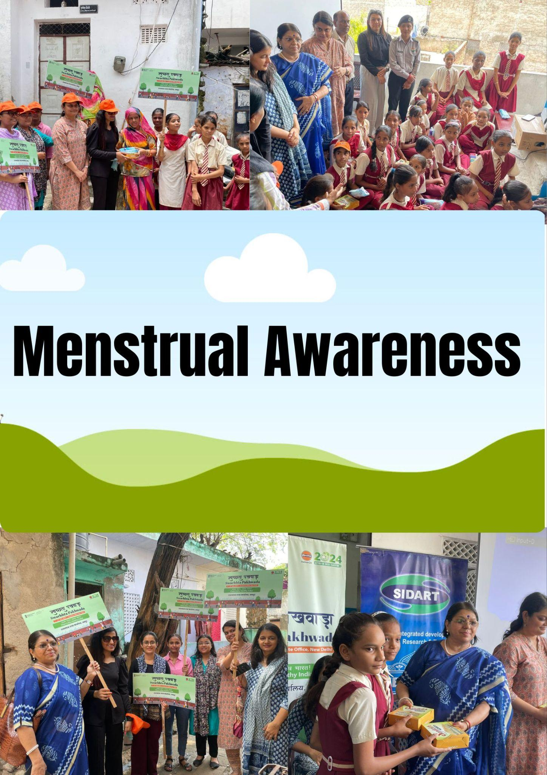
About the SIDART
SIDART (Society for Integrated Developmental Activities Research and Training) has worked for a long time for improving and develop the health of citizens of the Rajasthan state, established in 1.1.1998 under the Rajasthan Societies Registration Act on 23rd of April 1998 and now it was registered to work PAN India. SIDART organization works for women and child empowerment in the city and village level. SIDART realizes the importance of local wisdom, knowledge, and resources and uses a facilitative (not directive) approach. SIDART work aims to break the vicious cycle of poverty, social isolation and to restore hope for a better future. We believe that every person has the right to access resources and opportunities to live and develop with dignity and to become an active and contributing member of our society. “To develop a better society for the better development of citizen life."
Realize the rights of the people and help others to realize the needs of everyone. Explore, promote, disseminate and strengthen the ways to help those who are in need. Keep working for the betterment of others.
Mission: -
Empowerment of the marginalized and poor especially children and women enabling them to resist exploitation arising out of class, caste, and gender by using their physical resources to protect, nurture and sustain values that guarantee gender at personal, familial, social, political and institutional levels, address the right to life, through road safety trainings and programs.

About IOC (Indian Oil Corporation):
Indian Oil Corporation Limited (IOCL) is India's largest commercial enterprise, with a significant presence in the petroleum sector. It is a state-owned oil and gas company headquartered in New Delhi. IOCL operates a vast network of refineries, pipelines, and marketing infrastructure across the country. The company is involved in refining, transportation, and marketing of petroleum products including fuels, lubricants, and petrochemicals. IOCL plays a cruciaZl role in India's energy security and economy, catering to diverse sectors including transportation, industry, and households.

About the Menstrual Hygiene and Health, Adolescent and Young Women: -
A menstrual hygiene program is needed for young girls in faculties from class sixth to twelfth in 6 colleges / region in Jaipur,India to cope with the unique challenges they face in coping with their menstrual fitness. inadequate get admission to to smooth water, sanitation facilities, and affordable menstrual merchandise can cause unhygienic practices and multiplied threat of infections. via imposing a menstrual hygiene application, we will teach and empower those young women with understanding approximately menstrual fitness, right hygiene practices, and get admission to to affordable and sustainable menstrual merchandise. This software objectives to improve their standard properly-being, sell dignity, and ensure that they can absolutely participate of their each day activities without any drawback.

Activities :
1. On July 12, 2024, something very important happened at Tila No. 3 Jawahar Nagar Slum Mamta Bal Niketan School. The Indian Oil Corporation (IOC) organized a workshop to teach teenage girls and school staff about menstruation. This workshop was led by Shree Hanuman Ji Berwa and supported by a team from IOC who were passionate about educating the community.
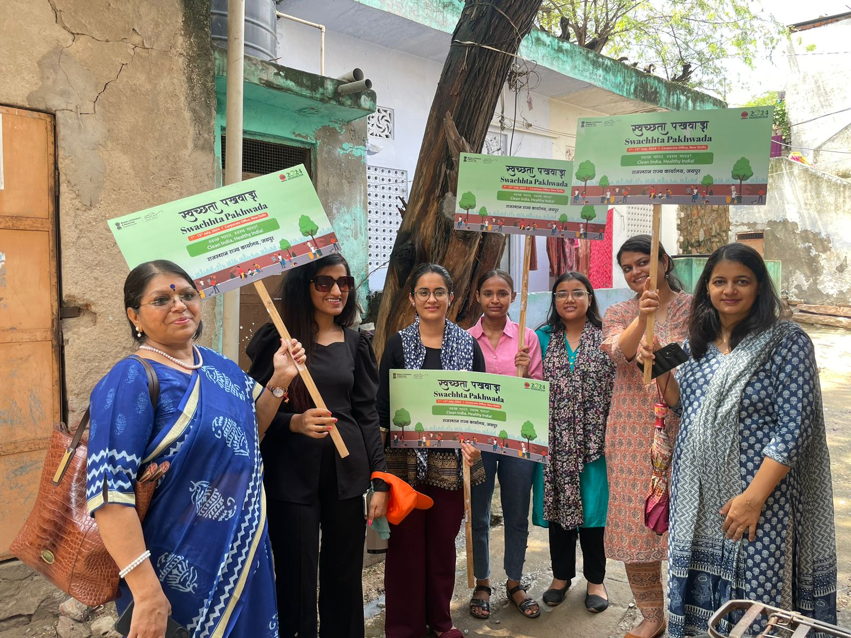

Dr. Pramila Sanjaya, a national expert on menstrual health, was there to guide everyone on how to maintain good hygiene during menstruation. The workshop wasn't just lectures — it was interactive! They talked about common misunderstandings about periods and even acted out scenarios to help everyone understand better.

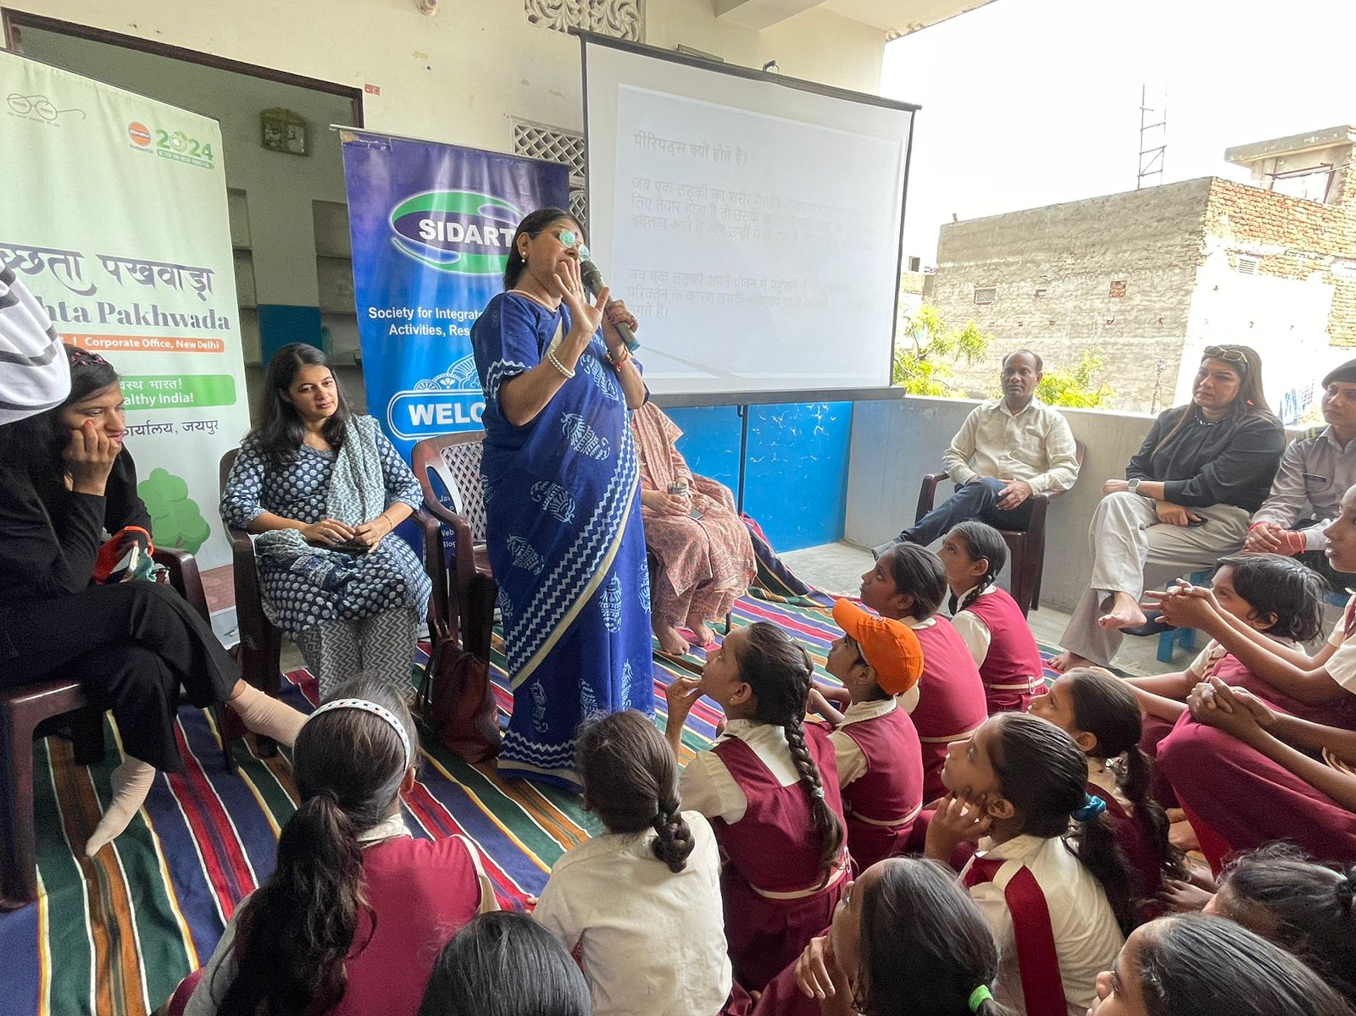
CP Sharma the national coordinator started the event and made all the arrangements. Vrinda and Swastik being the volunteers from SIDARTt helped with the overall management and arrangements of the event. Swati Saxena, an important leader at IOC, played a big role in making sure the workshop went smoothly. Mr CP Sharma started the seminar and the after the introduction round Dr. Pramila Sanjaya Discuss both formally and informally in detail with the girls present from the school from class 6 to class 8 about menstrual hygiene health and sanitation as well as the issues related to that where they need to consult the doctor and not feel any shame or about it. Ms Swati Saxena from IOC Was instrumental in coordinating with Dr Pramila Sanjaya and team at SIDART to organize such a meaningful event at the slum area where it is so much required looking into the level of unawareness and the health issues that they are related to regarding health hygiene sanitation and specially for the young girls where talking about menstrual hygiene is such a big taboo.
Officially started the workshop together.This showed the commitment of IOC regarding helping the communities and teaching the people about such an important topic of menstrual hygiene along with health sanitation etc.

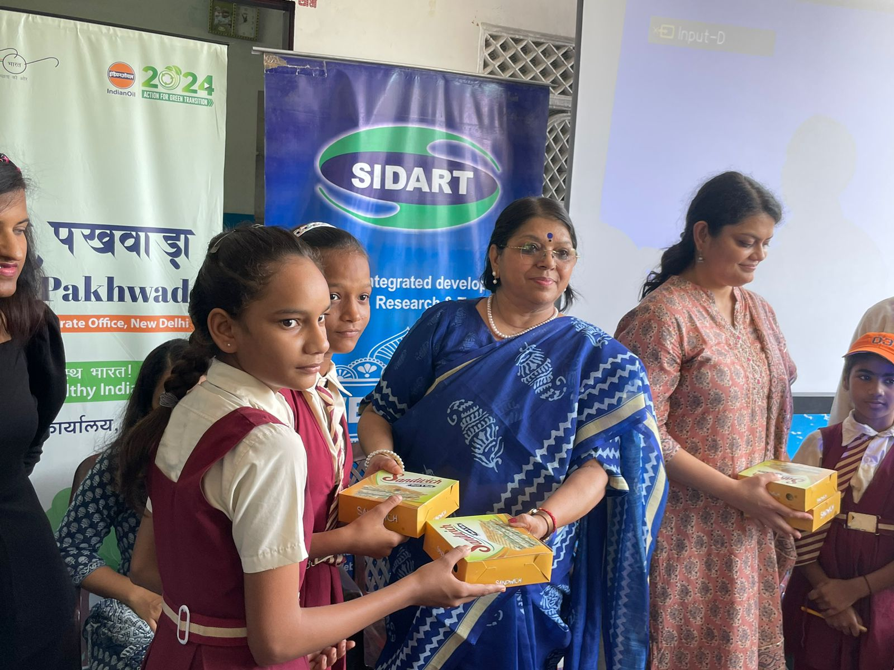

The workshop was a one-time thing for now as a part of swachta pakhwara(1st to 15th July 2024) but hopefully we will do many more seminars with IOC in the areas where it is required, for the vulnerable and blackboard areas like slums.Other members of the IOC team were there too, and they're committed to doing similar workshops at other places. They want to help more people learn about menstrual health and make sure everyone has the right information.
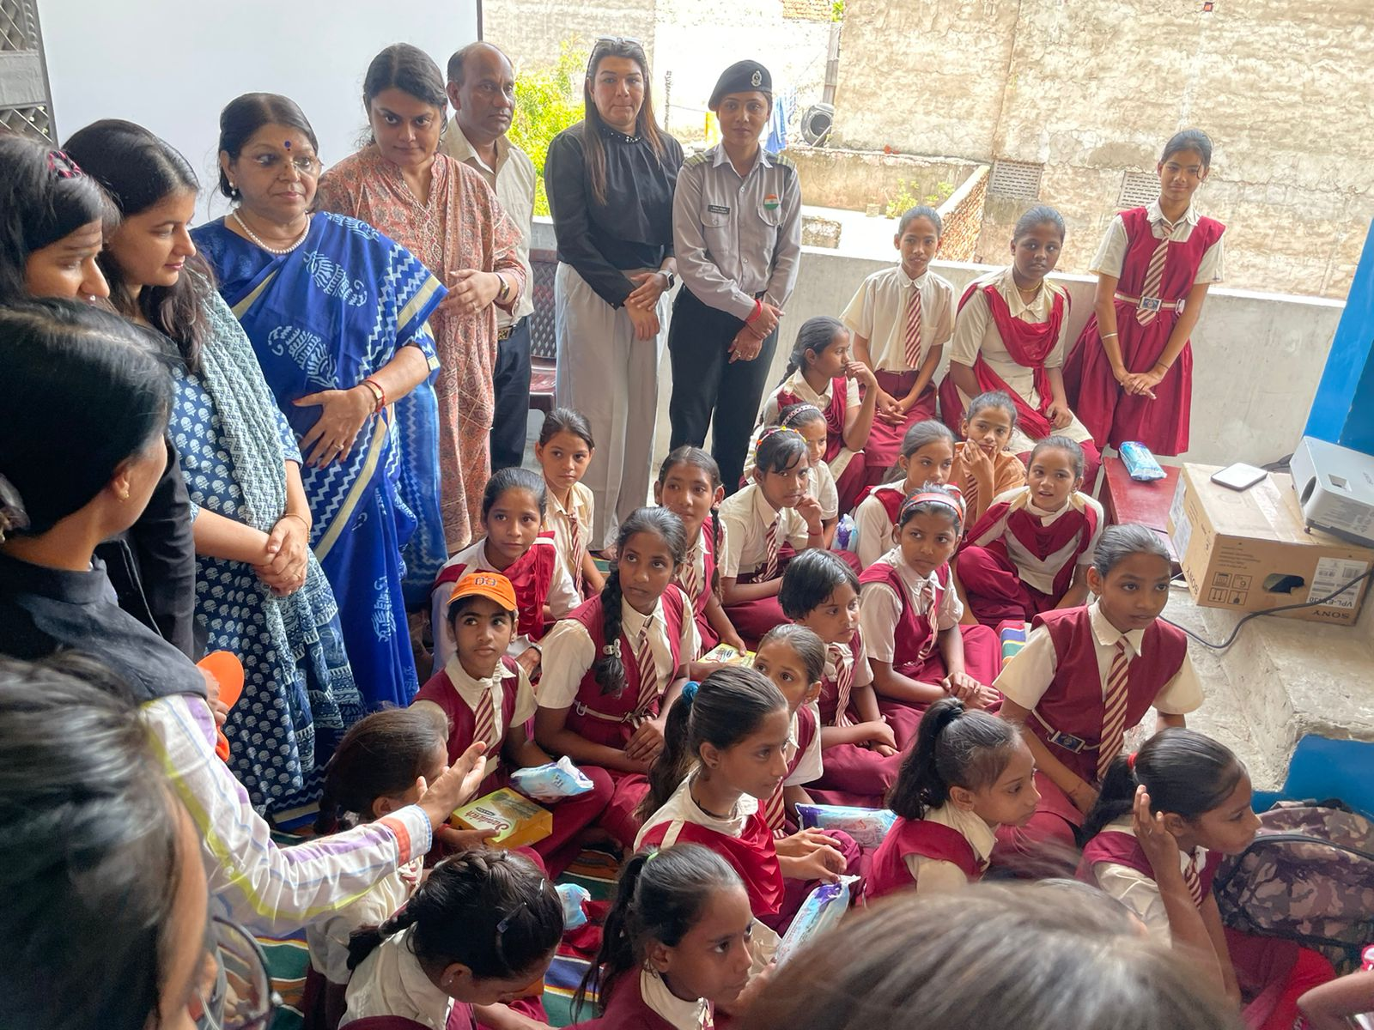
Overall, this workshop was about more than just learning facts. It was about making sure young girls and everyone in the married unmarried girls and women in the community, who might not be school going, feels supported and informed about something that is a natural part of life. IOC's efforts show that they care about the well-being of people beyond just their business, and they're making a real difference in people's lives.
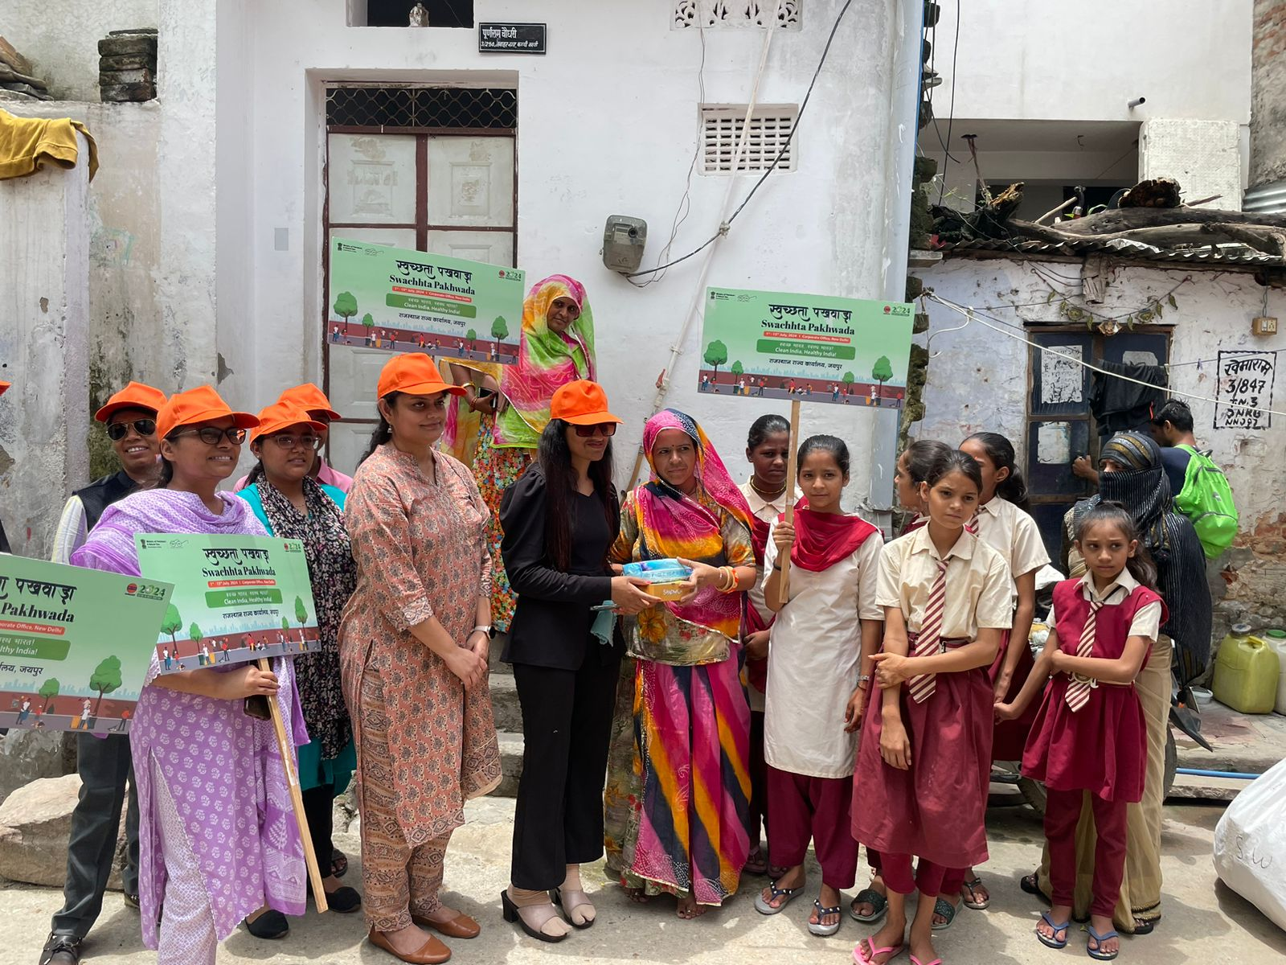
Benefits:
- Awareness in the community: This is an opportunity to bring the community on board about this whole issue of menstruation and it does not remain taboo and stigmatized.
- Empowering Young girls and women In the slum: The program aimed to empower young girls and women in the slum area near the school, with knowledge about their body and menstruation. This can help them manage their periods with confidence and dignity And also get rid of a lot of myths and misconceptions.
- Improved Hygiene: By promoting cleanliness practices, the program likely addressed issues related to menstrual hygiene management (MHM). This can contribute to better health and well-being of girls.
- Reduced Stigma: Open discussions and education can help break the silence and stigma surrounding menstruation. This can create a more supportive environment for girls. They can ask questions, get answers and if need be there can be a medical check up and one to one counseling session as well.

SIDART is looking for more partners to take it up in various other parts of the slums there are many informal settlements in Jaipur as per municipal corporation information and lot of such training programme and capacity building awareness generation is required from time to time

